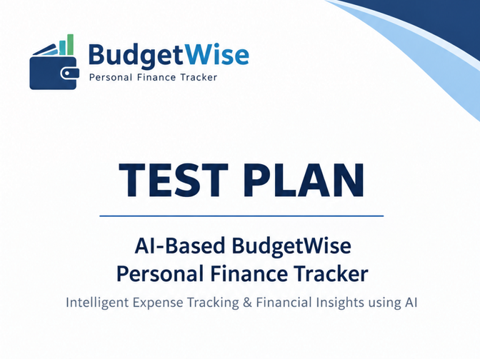


Table of Contents

Overview .....................................................................………………………………………………...2
Scope ..............................................................................................................................................2
Inclusions ........................................................................................................................................2
Test Environment ........................................................................................................................... 3
Exclusions ...................................................................................................................................... 3
Test Strategy .................................................................................................................................. 3
Defect Reporting Procedure .......................................................................................................... 5
Roles / Responsibilities .................................................................................................................. 5
Test Schedule ................................................................................................................................ 6
Test Deliverables ........................................................................................................................... 6
Pricing ............................................................................................................................................ 6
Entry and Exit Criteria .................................................................................................................... 7
Suspension and Resumption Criteria ............................................................................................. 7
Tools .............................................................................................................................................. 8
Risks and Mitigations ..................................................................................................................... 8
Approvals ....................................................................................................................................... 8

Overview

BudgetWise is a personal finance tracking web application developed to help users manage expenses, budgets, savings goals and financial information. The application uses a React.js frontend, a Java Spring Boot backend running on Tomcat, and a MySQL database. This document provides the high-level test planning details covering the scope, test strategy, environment, test schedule, deliverables, entry/exit criteria, risks and responsibilities for testing the application.

Scope
The scope of testing includes the following major functional areas of the BudgetWise web application.

Inclusions
The testing scope includes the following areas:
- User Registration, Login and Logout
- Dashboard: Monthly spend, total budget, budget status and recent transactions
- Expenses and Transactions: Add, view, edit and delete transactions
- Budgets: Create and manage category-wise spending limits
- Savings Goals: Create targets, track savings, transfer amounts and delete goals
- Categories and Accounts: Add, view and manage categories and accounts
- Reports and Charts: Validate financial reports and graphical data
- Settings: Profile, notifications, language and account management
- AI Expense Analysis: Validate expense analysis and generated financial insights
- Application Integration: Validate integration between React frontend, Spring Boot backend and MySQL database

Test Environment
- Operating System: Windows 11
- Primary Browser: Google Chrome
- Compatibility Browser: Microsoft Edge
- Frontend: React.js running in the local test environment

Exclusions
- Features outside the defined Budget-Wise application scope
- Third-party payment gateways and external services not implemented in the application
- Production infrastructure and deployment testing
- Full-scale performance, load, and stress testing
- Automation Testing is not Primary Scope

Test Strategy
Testing will be performed using a requirement-based and risk-based approach. Test scenarios and detailed test cases will be prepared for each functional area within the defined scope. Positive, negative, boundary and missing-input conditions will be considered while creating test cases. Appropriate test design techniques such as Equivalence Partitioning, Boundary Value Analysis, Decision Table Testing, State Transition Testing and Use Case Testing will be applied where applicable. Error Guessing and Exploratory Testing will also be used to identify defects that may not be covered by the planned test cases. Test cases will be prioritized according to business impact and risk.

Step #1 – Test Scenario and Test Case Creation
1 – Test Scenario and Test Case Creation: Test scenarios will first be prepared for each BudgetWise module and for important user workflows. Detailed test cases will then be created with appropriate positive and negative conditions, including valid, invalid, boundary and missing inputs. Test design techniques will be selected according to the functionality being tested, and exploratory testing and error guessing will be used in addition to planned test cases. Test cases will be prioritized so that critical financial and user-account functions receive appropriate coverage.
Test scenarios will be prepared for each Budget-Wise module and important user workflows. Detailed test cases will then be created using:
- Positive and negative test conditions
- Valid, invalid, boundary, and missing inputs
- Appropriate test design techniques
- Exploratory testing and error guessing
- Priority-based coverage for critical financial and user-account functions
Test cases will be reviewed to ensure sufficient coverage of the application requirements.

Step #2 – Test Execution
Step #2 – Test Execution: When a testable application build is received, Smoke Testing will first be performed to confirm that the major application functions are available. If the smoke test fails because of a critical issue, detailed testing will be paused until a stable build is available. After the build passes smoke testing, functional test cases will be executed across the in-scope modules. Frontend behavior, Spring Boot API responses and MySQL data will be validated where applicable. Retesting will be performed after defect fixes, followed by regression testing to ensure that existing functionality has not been affected. Testing cycles will be repeated until the defined exit criteria are achieved.

Step #3 – Types of Testing
The following types of testing will be performed based on the module, test objective, and stage of the testing cycle:
- Smoke Testing
- Sanity Testing
- Functional Testing
- Integration Testing
- System Testing
- Regression Testing
- Retesting
- UI and Usability Testing
- Database Testing
- Exploratory Testing

Step #4 – End-to-End Testing
Step #4 – End-to-End Testing: End-to-end testing will verify complete user journeys across the React frontend, Spring Boot backend and MySQL database. For example, a user registration and login flow can be followed by adding an expense, verifying the dashboard calculation, creating a budget, checking spending progress and validating the corresponding data stored in the database.

Defect Reporting Procedure
During test execution, any deviation between the expected and actual behavior of the application will be recorded as a defect or observation. Each defect will contain a clear summary, preconditions, steps to reproduce, expected result and actual result, along with screenshots or other supporting evidence where appropriate. Severity and priority will be assigned according to the impact of the issue. Defects will be reported to the development team using the agreed tracking method. Once a fix is provided, the defect will be retested and related functionality will be regression tested where necessary. Test cases and defect information will be maintained in the agreed documentation or tracking tool.

Roles / Responsibilities
Role | Responsibilities | Key Activities
Tester | Plan and execute testing activities | Create scenarios/test cases, execute tests, report defects, retest fixes, regression testing
Developer | Develop and maintain application functionality | Analyze defects, fix issues, provide updated builds, support technical clarification
Project Guide / Lead | Review testing progress and deliverables | Review scope, monitor progress, clarify requirements, review final results

Test Schedule
The following activities are planned for the testing cycle:
Task | Planned Duration
Requirement Review & Test Plan | 04.07.2026 – 05.07.2026
Test Scenario & Test Case Creation | 06.07.2026 – 08.07.2026
Test Environment & Test Data Setup | 09.07.2026 – 10.07.2026
Smoke & Functional Test Execution | 11 /07/2026
API & Database Validation | 12/07/2026
Defect Reporting & Retesting | 13/07/2026
Regression Testing | 13/07/2026
Test Summary Report | 14/07/2026

Test Deliverables
Deliverable | Description | Target
Test Plan | Scope, strategy, environment, schedule, criteria, risks and responsibilities | Planned Date
Test Scenarios | High-level scenarios covering in-scope modules | Planned Date
Functional Test Cases | Detailed test cases with steps, data and expected results | Planned Date
Defect Reports | Defects identified during execution with evidence and reproduction steps | As Identified
Test Execution Report | Execution status showing Passed, Failed, Blocked and Not Executed cases | Planned Date
Test Summary Report | Overall test results, defect summary and final test status | Final Date

Pricing
N/A – This is a project-level testing activity for the BudgetWise application.

Entry and Exit Criteria

Entry Criteria
Testing can begin when the required application requirements or module descriptions are available, a testable build is provided, the React frontend, Spring Boot backend and MySQL environment are configured, required test data and user accounts are available, and the major application dependencies are operational. Initial test scenarios and test cases should also be prepared before detailed execution begins.

Exit Criteria
Testing can be completed when the planned critical and high-priority test cases have been executed, critical or blocking defects have been resolved or formally accepted, fixed defects have been retested, required regression testing has been completed, and the test results and defect status have been documented. A final test summary report will be prepared to record the overall testing outcome.

Suspension and Resumption Criteria

Suspension Criteria
Testing may be suspended when the application cannot be launched or accessed, when a critical functionality required for further testing is unavailable, when the backend or database is unavailable for a prolonged period, when a high-impact defect blocks a major portion of the test scope, or when required test data or environment resources are unavailable.

Resumption Criteria
Testing will resume after a stable application build is provided, blocking defects are fixed or an approved workaround is available, the frontend, backend and database services are operational, and the required test data and environment have been restored and verified.

Tools
Microsoft Excel will be used for maintaining test scenarios, test cases and execution results. Postman will be used for REST API testing and response validation. MySQL Workbench will be used for database validation. Jira may be used for defect tracking if it is configured for the project. Google Chrome and Microsoft Edge will be used for web application testing, while Spring Boot and Tomcat logs may be reviewed for backend troubleshooting and validation.

Risks and Mitigations
Risk | Mitigation
Backend server unavailable | Verify Spring Boot/Tomcat service before execution and coordinate for recovery.
Database connection failure | Verify MySQL service, connection properties and database availability.
Requirement changes | Review changes and update impacted scenarios and test cases.
Defect blocks testing | Prioritize the defect and resume blocked cases after a fix or approved workaround.
Incorrect financial calculations | Validate calculations using independent expected values and database records.
Data inconsistency between UI and database | Perform frontend, API and MySQL validation for important transactions.
Browser compatibility issue | Perform supported browser checks and document browser-specific defects.
Insufficient test data | Prepare positive, negative and boundary test data before execution.

Approvals
The test plan and testing activities will be reviewed and approved by the responsible project stakeholders before test execution begins. Approval confirms that the scope, test approach, environment, and responsibilities are agreed upon.
Name | Role | Approval / Date
Hemprasath K | Tester | dd/mm/year
1-2-3 | Project Guide / Test Lead | dd/mm/year
x-y-z | Developer | dd/mm/year

